IPV4 ADDRESSES
To uniquely identify each device on the internet, is IP Address. Ipv4 has 32-bit address (4-byte address or 4-Octect address)
Two notation are commonly used for IPv4 addresses; Binary Notation and Dotted Decimal notation.

Binary notation: 01110101 10010101 00011101 11101010
Dotted Decimal notation: 117 . 149 . 29 . 234

CLASSFUL ADDRESSING
Netid and Hostid

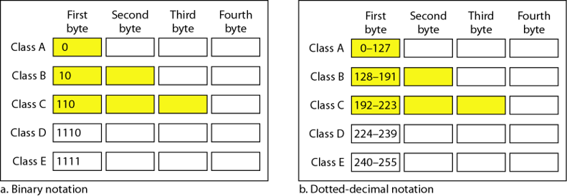

Addresses for private network
Class | Net IDs | Blocks
A | 10 | 1
B | 172.16 ~ 172.31 | 16
C | 192.168.0 ~ 192.168.255 | 256

Default masks for classful addressing
Class | Binary | Dotted-Decimal | CIDR
A | 11111111 00000000 00000000 00000000 | 255.0.0.0 | 8
B | 11111111 11111111 00000000 00000000 | 255.255.0.0 | 16
C | 11111111 11111111 11111111 00000000 | 255.255.255.0 | 24

First Address The first address in the block can be found by setting the 32 - n rightmost bits in the binary notation of the address to 0s (using AND logic operation)
Last Address The last address in the block can be found by setting the 32 - n rightmost bits in the binary notation of the address to 1s. (using OR logic operation).

Network and Broadcast Addresses
The first address is called the network address and defines the organization itself to the rest of the world and is used by routers to direct the message sent to the organization from the outside. The last address is called Broadcast address and is used to forward a message to all nodes in the given network.

SUBNETING CLASS C ADDRESSES
In a Class C address, only 8 bits are available for defining the hosts.
Remember that subnet bits start at the left and go to the right, without skipping bits.
This means that the only Class C subnet masks can be the following:
Binary  (4th Octect) | Decimal  (4th Octect) | CIDR (for Public IP) | Number of subnets | Number of hosts per subnet | Valid subnets  (4th Octect) | Broadcast Address for each subnet
10000000 | 128 | /25 | 2 | 128 - 2 | 0, 128 | 127, 255
11000000 | 192 | /26 | 4 | 64 - 2 | 0, 64, 128, 192 | 63, 127, 191, 255
11100000 | 224 | /27 | 8 | 32 - 2 | Calculate yourself
11110000 | 240 | /28 | 16 | 16 - 2
11111000 | 248 | /29 | 32 | 8 - 2
11111100 | 252 | /30 | 64 | 4 - 2

We can’t use a /31 or /32 because we have to have at least 2 host bits for assigning IP addresses to hosts.

After choosing a possible subnet mask for the network, it is needed to determine the number of subnets, valid hosts, and broadcast addresses of a subnet that the mask provides. The questions to be answered are:
(At this point it’s important that you both understand and have memorized your powers of 2.)

How many subnets? 2^{x} = number of subnets. x is the number of masked bits, or the 1s. For example, in 11000000, the number of ones gives us 2² subnets. In this example, there are 4 subnets.

How many hosts per subnet? 2^{y}– 2 = number of hosts per subnet. y is the number of unmasked bits, or the 0s. For example, in 11000000, the number of zeros gives us 2⁶ – 2 hosts. In this example, there are 62 hosts per subnet. You need to subtract two for the subnet address and the broadcast address, which are not valid hosts.

What are the valid subnets? 256 – subnet mask = block size, or increment number. An example would be 256 – 192 = 64. The block size of a 192 mask is always 64. Start counting at zero in blocks of 64 until you reach the subnet mask value and these are your subnets.
0, 64, 128, 192.
that is, if you can count in the needed block size!

Example:
192.168.10.0 = Network address
255.255.255.128 (/25) = Subnet mask
Solution:
No. of subnets= 2¹ = 2.
No. of hosts per subnet= 2⁷ – 2 = 126 hosts.
valid subnets address: 0 and 128, since Block Size = 256 – 128 = 128.
Subnet Address | First Host Address | Last Host Address | Broadcast Address
192.168.0.0 | 192.168.0.1 | 192.168.0.126 | 192.168.0.127
192.168.0.128 | 192.168.0.129 | 192.168.0.254 | 192.168.0.255

SUBNETING CLASS B ADDRESSES
The Class B network address has 16 bits available for hosts addressing. This means we can use up to 14 bits for subnetting since we must leave at least two bits for host addressing. This means that the Class B subnet masks can be the following:
Binary (3rd and 4th Octect) | Decimal (All Octects) | CIDR (Classless Inter-Domain Routing)
10000000 00000000 | 255.255.128.0 | /17
11000000 00000000 | 255.255.192.0 | /18
11100000 00000000 | 255.255.224.0 | /19
11110000 00000000 | 255.255.240.0 | /20
11111000 00000000 | 255.255.248.0 | /21
11111100 00000000 | 255.255.252.0 | /22
11111110 00000000 | 255.255.254.0 | /23
11111111 00000000 | 255.255.255.0 | /24
11111111 10000000 | 255.255.255.128 | /25
11111111 11000000 | 255.255.255.192 | /26
11111111 11100000 | 255.255.255.224 | /27
11111111 11110000 | 255.255.255.240 | /28
11111111 11111000 | 255.255.255.248 | /29
11111111 11111100 | 255.255.255.252 | /30

Remember! In class B subnetting can be performed in two octets. So we have to check the block size etc. in both octets separately and then do the calculations for finding the subnet addresses and host and broadcast addresses.
Note: The Class A can be subnetted in the same way as for Class C and B. However, in that case we have subnetting possible in 3 octets as oppposed to 1 or 2 subnets as in Class C or B respectively.

Practice Example #1 for Class B: 255.255.128.0 (/17)
172.16.0.0 = Network address
255.255.128.0 = Subnet mask

1_ How many subnets? Since 128 is 1 bit on (10000000), the answer would be 2¹.
2_ How many hosts per subnet? We have 15 host bits off (10000000 00000000), so the equation would be 2¹⁵ – 2 = 65,534 hosts.
3_ What are the valid subnets? 256 – 128 = 128. Remember, we start at zero and count in our block size, so our subnets are 0, and 128. (For 3rd octet only. There is no subnetting in 4th octet)

Subnet Address | First Host Address | Last Host Address | Broadcast Address
172.16.0.0 | 172.16.0.1 | 172.16.127.254 | 172.16.127.255
172.16.128.0 | 172.16.128.1 | 172.16.255.254 | 172.16.255.255

Practice Example #2 for Class B: 255.255.255.128 (/25)
172.16.0.0 = Network address
255.255.255.128 = Subnet mask
Solution:
No. of subnets= 2⁹ = 512 subnets
No. of hosts per subnet= 2⁷ – 2 = 126 hosts.
valid subnets address: 0.0, 0.128, 1.0, 1.128, 2.0, …, 255.0 and 255.128
since Block Size = 256 – 255 = 1. (For 3rd Octet)
and Block Size = 256 – 128 = 128. (For 4th Octet)

Subnet Address | First Host Address | Last Host Address | Broadcast Address
172.16.0.0 | 172.16.0.1 | 172.16.0.126 | 172.16.0.127
172.16.0.128 | 172.16.0.129 | 172.16.0.254 | 172.16.0.255
172.16.1.0 | 172.16.1.1 | 172.16.1.126 | 172.16.1.127
172.16.1.128 | 172.16.1.129 | 172.16.1.254 | 172.16.1.255
172.16.2.0 | 172.16.2.1 | 172.16.2.126 | 172.16.2.127
172.16.2.128 | 172.16.2.129 | 172.16.2.254 | 172.16.2.255
… | … | … | …
172.16.255.0 | 172.16.255.1 | 172.16.255.126 | 172.16.255.127
172.16.255.128 | 172.16.255.129 | 172.16.255.254 | 172.16.255.255

Implementing Variable Length Subnet Masks (VLSMs) Networks
As the name suggests, with VLSMs we can have different subnet masks for different router interfaces.
For a class C network, following subnets are possible.

Prefix | Mask | Block Size | Hosts
/25 | 128 | 128 | 126
/26 | 192 | 64 | 62
/27 | 224 | 32 | 30
/28 | 240 | 16 | 14
29 | 248 | 8 | 6
/30 | 252 | 4 | 2

Keep in mind that it doesn’t matter where you start your block sizes as long as you always count from zero. For example, if you had a block size of 16, you must start at 0 and count from there—0, 16, 32, 48, etc. You can’t start a block size of 16 from, say, 40 or anything other than increments of 16.

Practice Example for Class C network using VLSM: 192.168.10.0 /24
VLSM Sheet (/Chart)

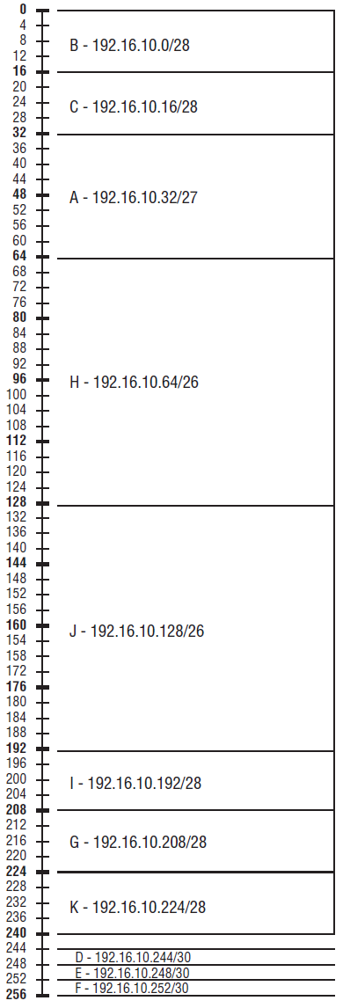

Figure shows a network with 11 networks. Create VLSM table by using block size chart to fill in the table with the subnets you need. This results in two block sizes of 64, one of 32, five of 16, and three of 4.

VLSM Table

Practice Example #2 for Class C network using VLSM: 192.168.10.0 /24

10 hosts
Net = B


5 hosts
Net = C
70 hosts
Net = A

30 hosts
Net = D

Create VLSM table for the above four networks. You must have to assign blocks following the name sequence of subnets, that is to assign IP address block to network A first, then B, then C and finally to D.

Subnet | Hosts required | Block size assigned | Subnet Mask (in binary) | Subnet Address | Broadcast Address
A | 70 | 128 | 11111111 11111111 11111111 10000000 | 192.168.10.0 | 192.168.10.127
B | 10 | 16 | 11111111 11111111 11111111 11110000 | 192.168.10.128 | 192.168.10.143
C | 5 | 8 | 11111111 11111111 11111111 11111000 | 192.168.10.144 | 192.168.10.141
D | 30 | 32 | 11111111 11111111 11111111 11100000 | 192.168.10.160 | 192.168.10.191

The block of 32, can start only with multiple of 32 block sizes. That is, it must be either be 0, 32, 64, 96, 128, 160, 192, or 224.

